HANOI UNIVERSITY OF SCIENCE AND TECHNOLOGY

School of Information and communications technology

Software Design Document

Version 1.3

AIMS - AN ONLINE MEDIA STORE

ITSS SOFTWARE DEVELOPMENT

**Group 10**

Nguyễn Trọng Huy – 20210451

Dương Văn Hữu – 20215210

Nguyễn Chấn Hưng – 20215209

Đặng Việt Hoàng – 20215206

Đặng Ngọc Huy - 20200270

*Hanoi, June 2024*

**Table of Contents**

1. Introduction 7

1.1. Objective 7

1.2. Scope 7

1.3. Glossary 8

1.4. References 11

2. Overall Description 12

2.1. General Overview 12

2.2. Assumptions/Constraints/Risks 12

2.2.1. Assumptions 12

2.2.2. Constraints 12

2.2.3. Risks 13

3. System Architecture and Architecture Design 14

3.1. Architectural Patterns 14

3.2. Interaction Diagrams 15

3.3. Analysis Class Diagrams 23

3.4. Unified Analysis Class Diagram 26

4. Detailed Design 27

4.1. User Interface Design 27

4.1.1. Screen Configuration Standardization 27

4.1.2. Screen Transition Diagrams 28

4.1.3. Screen Specifications 28

4.2. Data Modeling 42

4.2.1. Conceptual Data Modeling 42

4.2.2. Database Design 42

4.3. Class Design 47

4.3.1. General Class Diagram 47

4.3.2. Class Diagrams 48

4.3.3. Class Diagram for SubSystem 50

4.3.3.1.Email SubSystem 50

4.3.3.2. Payment SubSystem 50

4.4. Class Design Details 51

5. Design Considerations 59

5.1. Goals and Guidelines 59

5.2. Architectural Strategies 60

5.3. Coupling and Cohesion 61

5.4. Design Patterns 62

**List of Figures**

Figure 1 Place order sequence diagram 15

Figure 2 Place rush order sequence diagram 16

Figure 3 Pay order sequence diagram 16

Figure 4 Cancel order sequence diagram 17

Figure 5 Review order sequence diagram 17

Figure 6 CRUD products in cart sequence diagram 18

Figure 7 Search for products sequence diagram 18

Figure 8 Sort products by price sequence diagram 19

Figure 9 Login sequence diagram 19

Figure 10 CRUD products sequence diagram 20

Figure 11 CRUD users sequence diagram 21

Figure 12 Change password sequence diagram 22

Figure 13 Analysis entity class diagram 23

Figure 14 Analysis controller class diagram 24

Figure 15 Analysis boundary class diagram 25

Figure 16 Unified analysis class diagram 26

Figure 17 Screen transition diagram 28

Figure 18 ERD diagram 42

Figure 19 Database schema 43

Figure 20 General Class Diagram 47

Figure 21 Class diagram for Controller 48

Figure 22 Class diagram for Entity 48

Figure 23 Class diagram for Boundary 49

Figure 24 Email Subsystem Design 50

Figure 25 Payment Subsystem Design 50

Figure 26 Singleton for Cart class 62

Figure 27 Singleton for SimplejavamailConfig class 63

Figure 28 Template method design pattern for DAO 64

Figure 29 Strategy design pattern 65

**List of Tables**

Table 1 Glossary 8

Table 2 Cart Screen 28

Table 3 Delivery Form Screen 29

Table 4 Rush Delivery Form Screen 30

Table 5 Invoice Screen 31

Table 6 Pay Order Form 32

Table 7 Success Order Screen 33

Table 8 Invalid Form Screen 34

Table 9 Invalid Rush Order Screen 35

Table 10 Login Screen 35

Table 11 Home Screen 36

Table 12 Admin Screen 37

Table 13 Product Manager Screen 39

Table 14 Change Account Password Screen 40

Table 15 Media Table Details 43

Table 16 DVD Table Details 43

Table 17 CD_and_LP Table Details 44

Table 18 Book Table Details 44

Table 19 User Table Details 44

Table 20 DeliveryInfo Table Details 45

Table 21 OrderInfo Table Details 45

Table 22 RushOrderInfo Table Details 45

Table 23 OrderInfo_Media Table Details 46

Table 24 Payment Transaction Table Details 46

Table 25 Invoice Table Details 46

# Introduction

The Software Design Document (SDD) serves as a comprehensive guide for the software development process, providing detailed descriptions of the architecture, components, interfaces, and data for a software system. This document outlines the design decisions and approaches used to achieve the project requirements, ensuring that all stakeholders have a clear understanding of the system's structure and functionality. The SDD encompasses various subsections that detail the overall system architecture, module design, data design, and interface design, among others. By offering a thorough overview, the SDD aims to facilitate communication among team members, enhance system maintainability, and support future development and enhancements.

## Objective

The purpose of this Software Design Document (SDD) is to provide a detailed blueprint of the software architecture, design decisions, and implementation plans for the development team. It serves as a crucial reference that ensures consistency, clarity, and alignment throughout the software development lifecycle. The intended audience for this SDD includes software developers, system architects, project managers, quality assurance testers, and other stakeholders involved in the project. By clearly documenting the design specifications, this SDD aims to facilitate effective communication, streamline the development process, and ensure that the final software product meets the specified requirements and standards.

## Scope

This AIMS – ‘An Internet Media Store’ software is developed to be a desktop platform e-commerce software, which helps users to order media products on the Internet, and the store managers, at the same time, are easier to manage their store as well as the orders.

This program is capable of catering to 1,000 clients concurrently with minimal impact on performance and can run uninterrupted for 300 hours without any issues. Moreover, it can return to regular functioning within a maximum of 1 hour following an incident. The software's response time ranges from 2 seconds under typical circumstances to 5 seconds during periods of peak activity.

In AIMS, customers can not only search for products, but also sort products as they desire, they can place an order or rush order for necessary cases. AIMS is supported for VNPay transactions; thus, customers can easily pay for their order. Moreover, customers can review their order and modify any information during the processing order stage. While shopkeepers can manage their store by managing products directly in the system. They, meanwhile, can process the orders of the customers. For administrators, they are capable of managing users and privilege problems of users.

Besides, for a desktop website, the need for a graphical user interface is also under consideration, which can meet the requirements of end users and enhance the experience of users. Throughout the development stage, every document is also recorded for the future maintenance and upgrading. We keep our focus on every stage to supervise the timeline of the client provided and the quality the software may deliver. If any change is made, our team will adapt quickly to revise our work.

## Glossary

Table 1 Glossary

|  |  |  |  |  |
| --- | --- | --- | --- | --- |
| **No** | **Term** | **Explanation** | **Example** | **Note** |
| 1 | session | A session is a temporary period of interaction or engagement between a user and a system, during which the user accesses and interacts with software or a website, and the system maintains relevant settings and information. | software session |  |
| 2 | VAT  (Value-added tax) | It is a type of consumption tax that is levied on the value added to goods and services at each stage of production or distribution. VAT is typically implemented as a percentage of the final selling price of a product or service, and it is collected by businesses on behalf of the government. |  |  |
| 3 | API  (Application Programming Protocol) | API is a set of rules, protocols, and tools that allows different software apps to communicate with each other. | VNPay API | AIMS connects to the API of VNPay for transactions. |
| 4 | Payment gateway | A technology service that facilitates the secure transmission of payment information between a merchant's website or application and the financial institutions involved in processing payment transactions. |  |  |
| 5 | GUI  (Graphical user interface) | Refers to the visual elements and interactive components of a software application that allow users to interact with the system using graphical icons, buttons, menus, and windows. |  |  |
| 6 | Credit card | A credit card is a payment card issued by a financial institution, such as a bank or credit union, that allows cardholders to borrow funds up to a predetermined limit to make purchases or pay for goods and services. |  | AIMS currently supports for credit card payment through VNPay |
| 7 | Authentication | Authentication is the process of verifying the identity of a user, device, or system attempting to access a resource or service. |  |  |
| 8 | Response time | Response time refers to the amount of time it takes for a system to respond to a user's request or input. |  |  |

## References

|  |  |
| --- | --- |
| [1] | Centers for Medicare & Medicaid Services, "System Design Document Template," [Online]. Available: https://www.cms.gov/Research-Statistics-Data-and-Systems/CMS-Information-Technology/XLC/Downloads/SystemDesignDocument.docx. |

# Overall Description

In this section, we deliver the main points in the SDD document, which include the overview and technical-view assumptions, constraints and risks for AIMS - An Online Media Store project.

## General Overview

The system context and basic design approach focus on creating a robust, scalable, and maintainable software solution. The system architecture follows a modular design, allowing for easy updates and integration with other systems. The software architecture employs a layered approach, separating concerns and ensuring clear interfaces between components. Design goals include high performance, security, and user-friendly interfaces. High-level context diagrams, such as general use case diagrams and activity diagrams, provide an overview of system interactions and workflows. Any updates to these diagrams reflect recent changes in requirements or understanding, ensuring the design remains aligned with current project needs.

## Assumptions/Constraints/Risks

### Assumptions

The design of the system is based on several key assumptions. It is assumed that the system will operate within a stable hardware environment, utilizing specific operating systems as outlined in the project requirements. The end-users are expected to have a basic level of technical proficiency, and any future changes in functionality will be minimal and manageable. Additionally, the system relies on the integration with related software components, which are assumed to be available and compatible as specified.

### Constraints

Several global constraints impact the design of the system. The hardware environment imposes limitations on processing power and memory, requiring optimization of software performance. The end-user environment demands a user-friendly interface accessible on various devices. Resource availability and potential volatility necessitate a design that can handle fluctuations efficiently. Compliance with industry standards and interoperability with existing systems are mandatory, influencing interface and protocol design. Licensing requirements must be adhered to, affecting software choices and costs. The data repository needs to ensure secure and efficient storage and distribution of information. Security requirements, including data protection and user privacy, are paramount. Performance requirements dictate the need for fast and reliable system responses. Network communications must support seamless data exchange, and rigorous verification and validation processes are necessary to maintain high quality and reliability. All these constraints collectively shape the system’s architecture and implementation.

### Risks

The system design is subject to various risks, including potential security vulnerabilities, resource limitations, and integration challenges. Security risks involve unauthorized access and data breaches, mitigated by implementing robust encryption and authentication mechanisms. Resource limitations, such as processing power and memory, are addressed through efficient coding practices and performance optimization. Integration challenges with existing systems and third-party components are managed by thorough testing and adherence to interoperability standards. Additionally, potential changes in user requirements or operating environments pose risks, which are mitigated by maintaining a flexible and modular design that can adapt to evolving needs. Regular risk assessments and mitigation strategies ensure that potential issues are identified and addressed proactively.

# System Architecture and Architecture Design

In this section, we propose the general overview of System Architecture Design. This starts from defining the Architectural Patterns, then we design the interaction diagram using sequence diagrams for the proposed architectural patterns. From the interaction diagrams, we can have the analysis class diagrams, which is the fundamental steps for the detailed-level class diagrams for implementation.

## Architectural Patterns

The Entity-Control-Boundary (ECB) architecture design pattern is a software design approach that helps in organizing and structuring code to enhance maintainability, scalability, and clarity. This pattern divides the system into three primary types of components: entities, controls, and boundaries.

Entities represent the core business logic and data of the application. These components encapsulate the main data structures and the operations directly related to the core functionality of the system. Entities are typically designed to be reusable and independent of the specific use cases. They model real-world objects and are responsible for managing and maintaining their state and behavior. For example, in a banking application, entities might include classes such as *Account*, *Customer*, and *Transaction*.

Controls are responsible for coordinating the flow of information between entities and boundaries. They manage the application's use cases, orchestrating the interactions between entities and ensuring the correct sequence of operations. Controls contain the logic that drives the application's processes, ensuring that user inputs are properly processed and that the necessary business rules are applied. For instance, a *PlaceOrder* control might handle the logic for executing a financial transaction, validating inputs, and updating account balances accordingly.

Boundaries define the interfaces through which the system interacts with external actors, such as users, other systems, or external services. They serve as the point of communication between the application and its environment, encapsulating the specifics of input and output mechanisms. Boundaries translate user actions into requests that the control components can handle and present the results back to the user. Examples of boundaries include user interface components like forms and buttons, web service interfaces, or API endpoints, which serve as subsystems in interface design.

We select this architecture pattern because many advantages it delivers:

- **Separation of Concerns**: By clearly dividing the system into entities, controls, and boundaries, the ECB pattern ensures a clean separation of concerns, making the codebase more modular and easier to understand.

- **Maintainability**: Changes in one part of the system (e.g., user interface changes) do not directly impact the core business logic encapsulated in entities, thereby reducing the risk of introducing bugs when making modifications.

- **Scalability**: The modular nature of the ECB pattern facilitates scalability. New features can be added by creating new controls and boundaries without altering existing entities.

- **Testability**: The clear separation between entities, controls, and boundaries enhances testability. Business logic can be tested independently of the user interface, and mock boundaries can be used to simulate interactions during testing.

## Interaction Diagrams

3.2.1 Place order

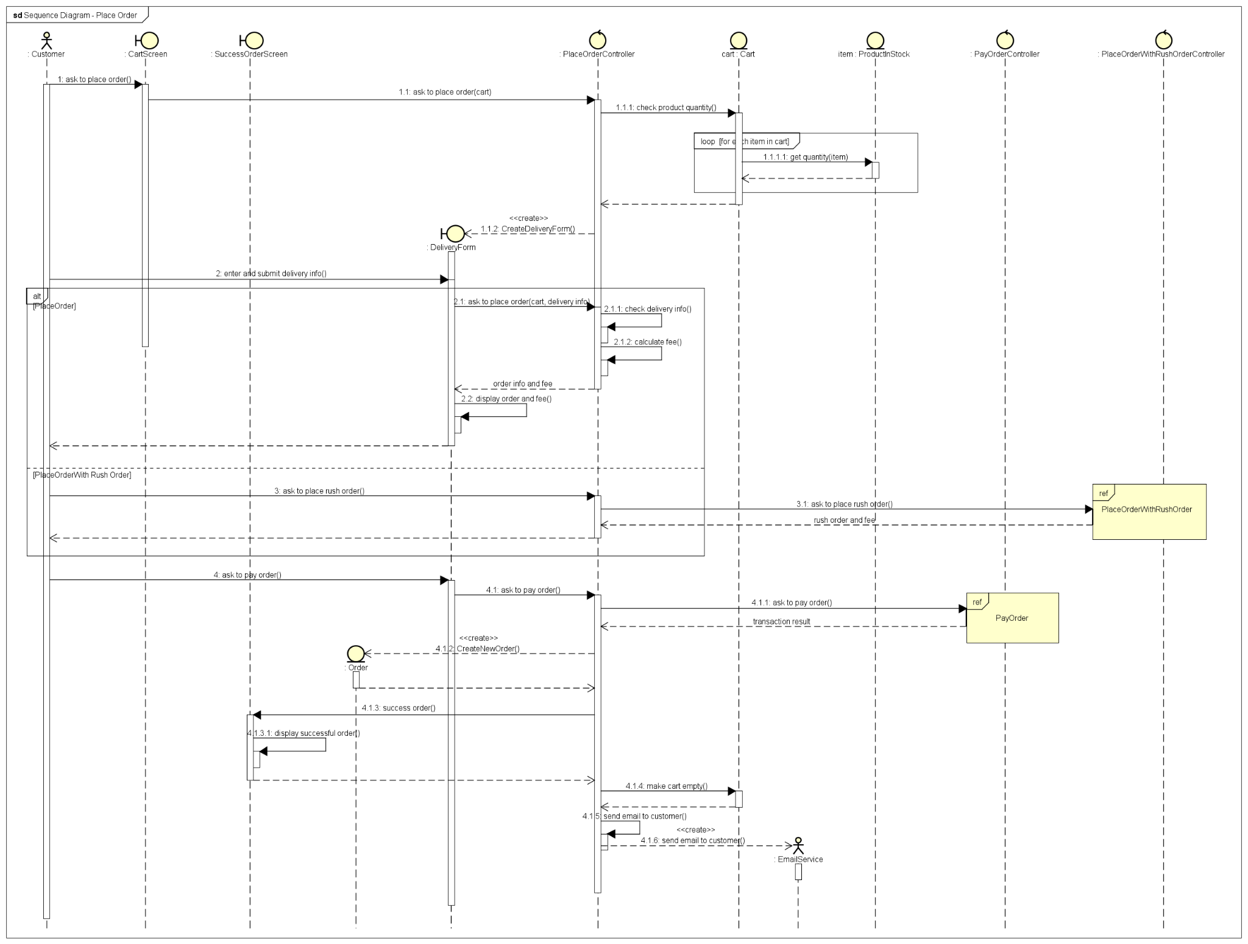

Figure 1 Place order sequence diagram

3.2.2 Place rush order

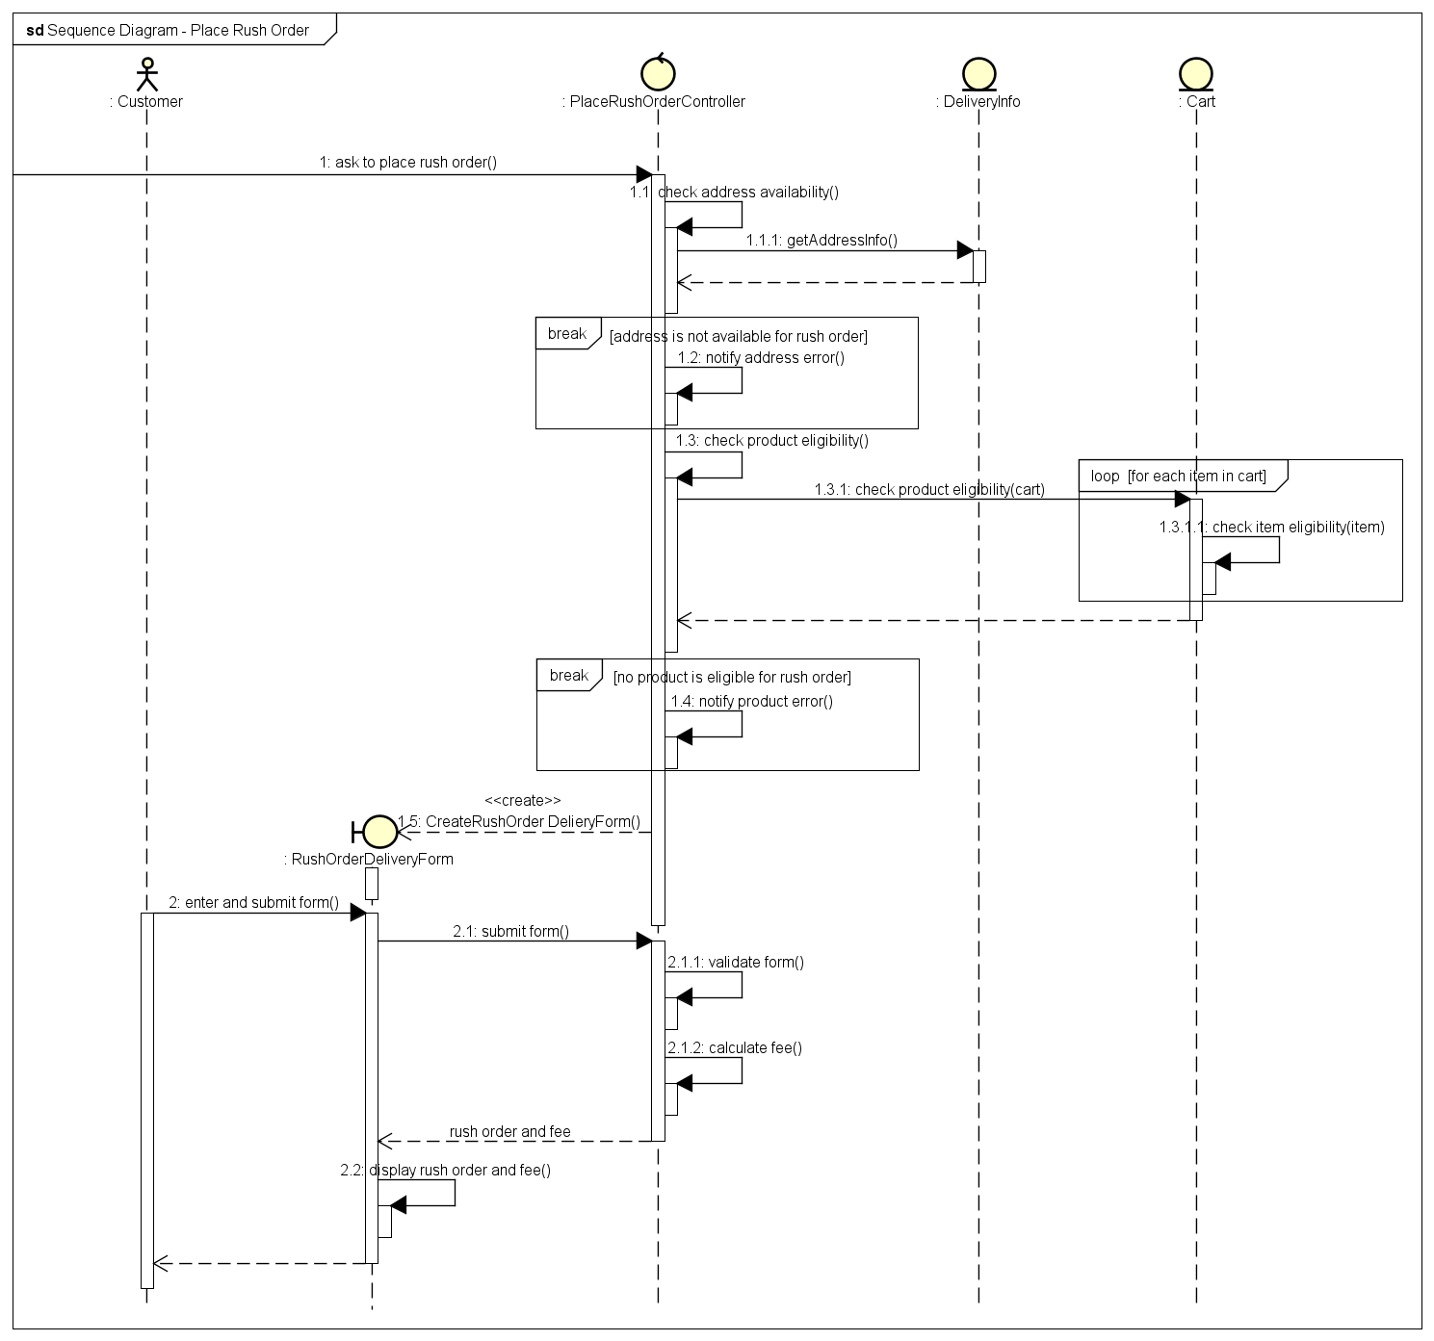

Figure 2 Place rush order sequence diagram

3.2.3 Pay order

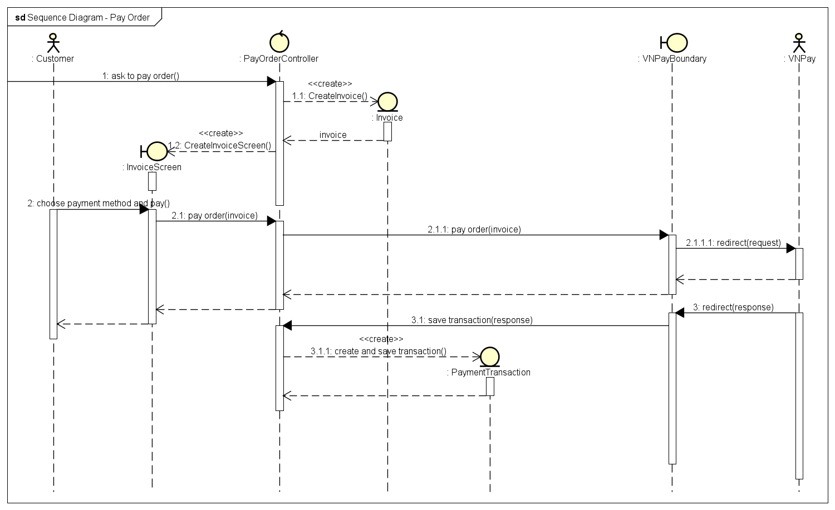

Figure 3 Pay order sequence diagram

3.2.4 Cancel order

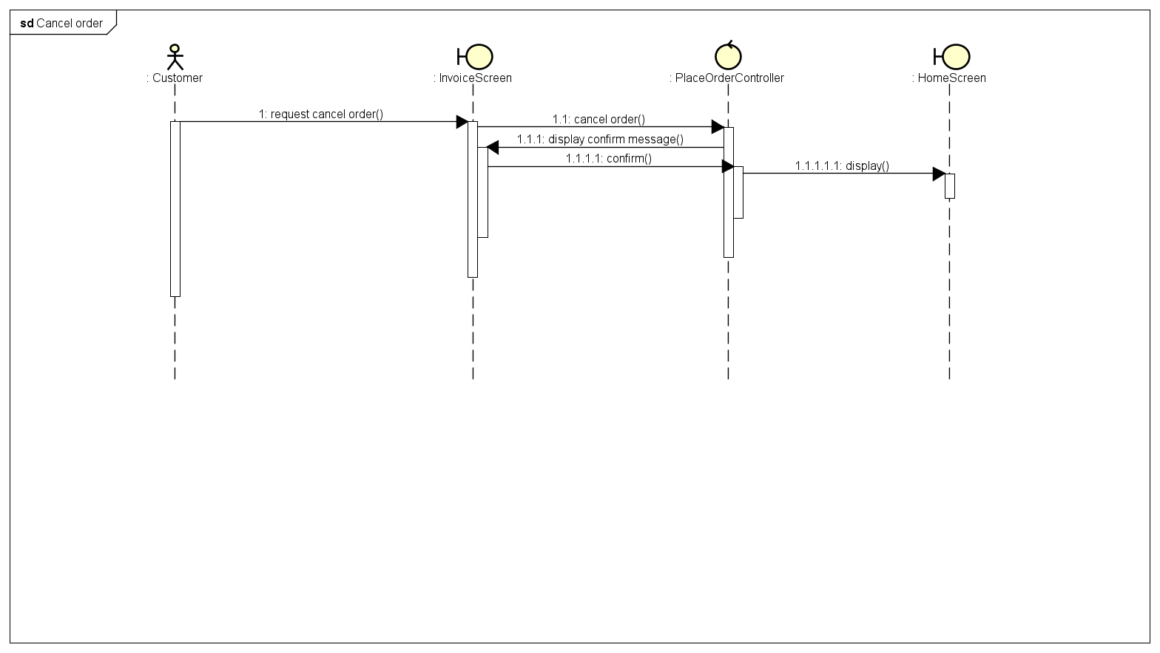

Figure 4 Cancel order sequence diagram

3.2.5 Review order

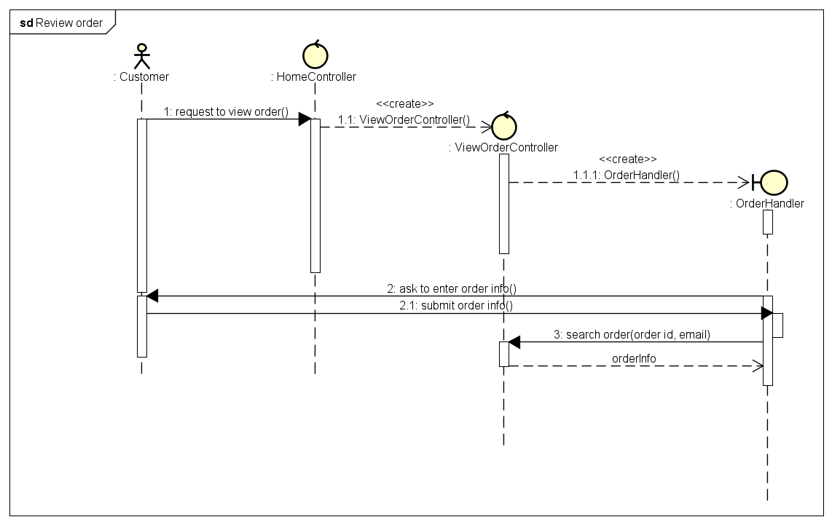

Figure 5 Review order sequence diagram

3.2.6 CRUD products in cart

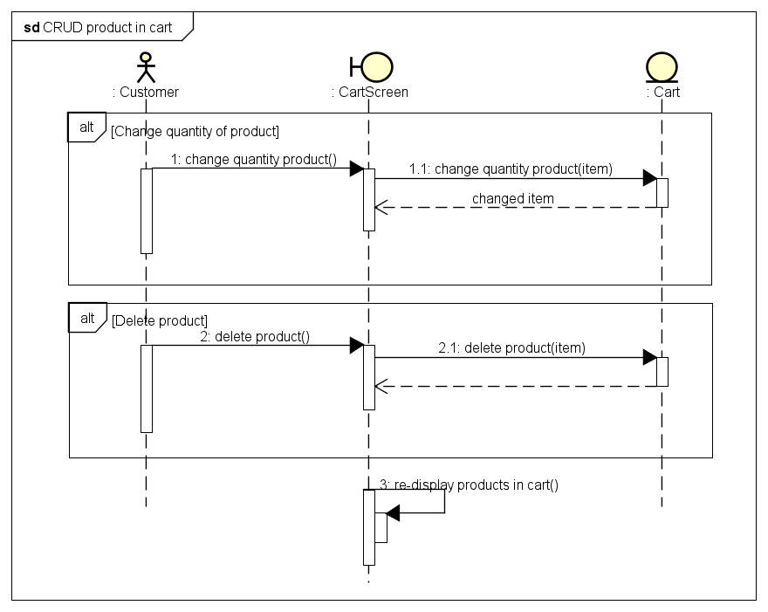

Figure 6 CRUD products in cart sequence diagram

3.2.7 Search for products

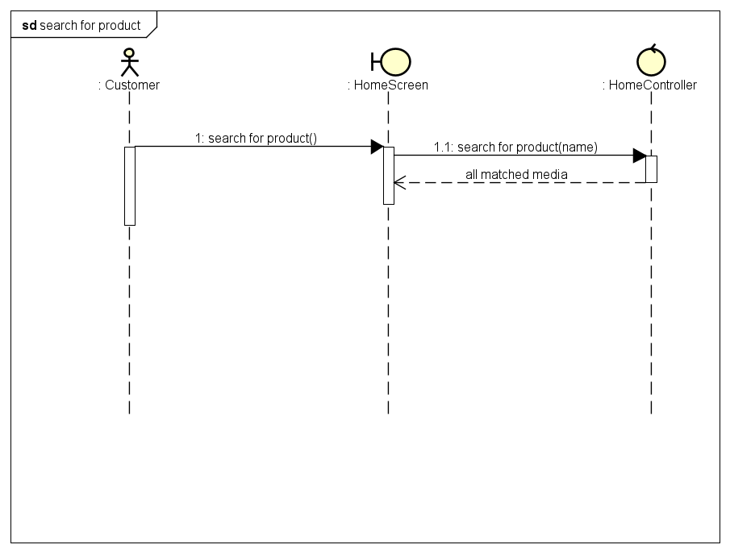

Figure 7 Search for products sequence diagram

3.2.8 Sort products by price

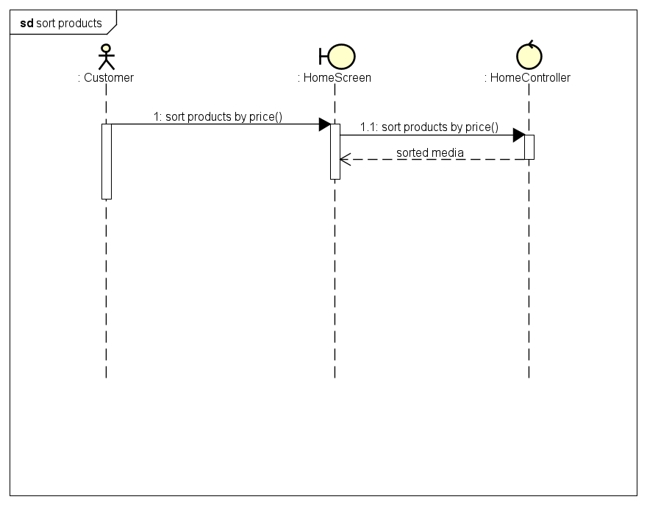

Figure 8 Sort products by price sequence diagram

3.2.9 Log in

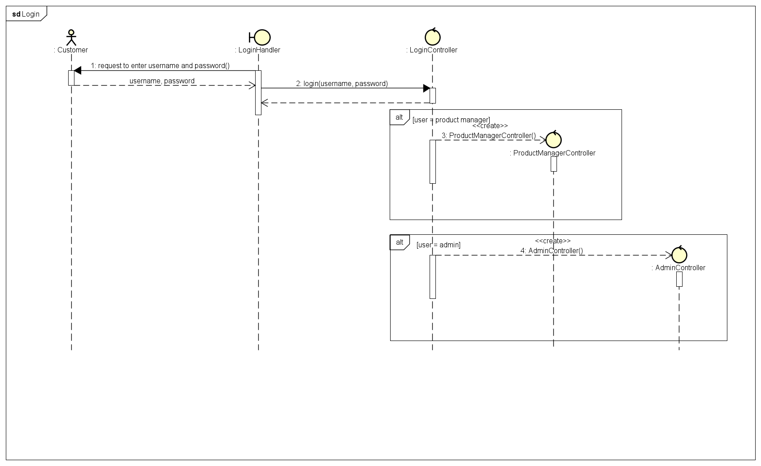

Figure 9 Login sequence diagram

3.2.10 CRUD products

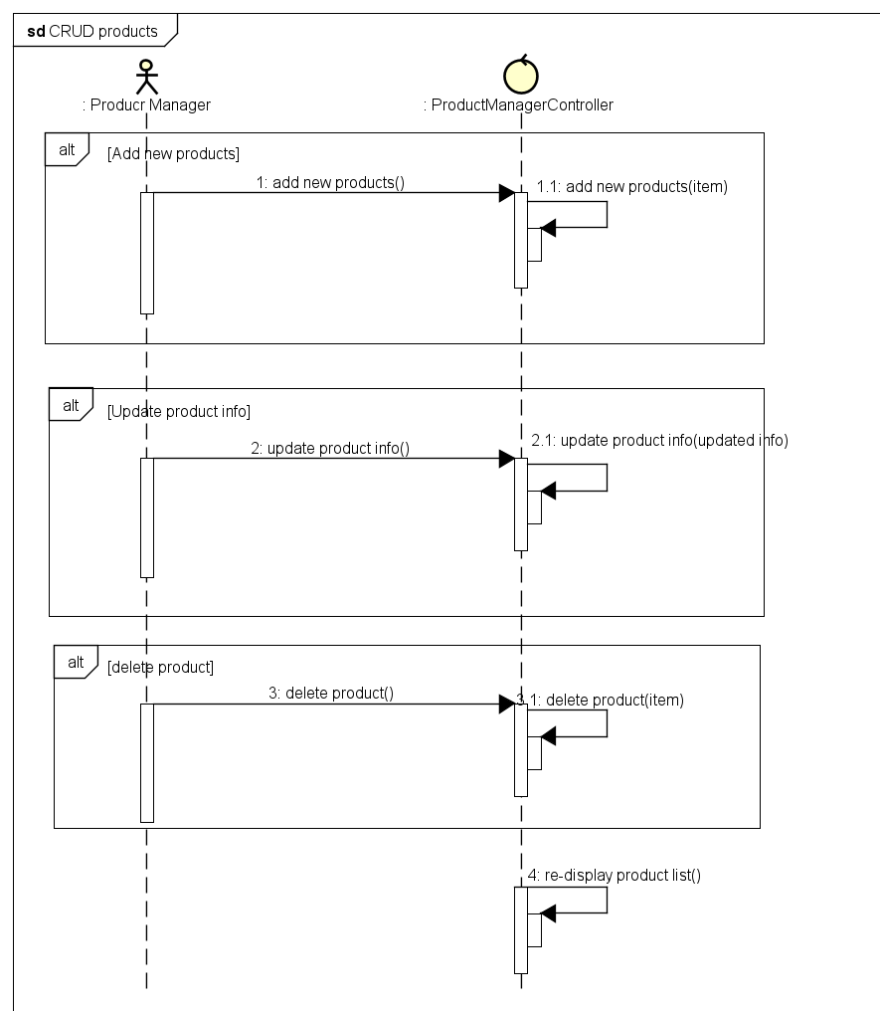

Figure 10 CRUD products sequence diagram

3.2.11 CRUD users

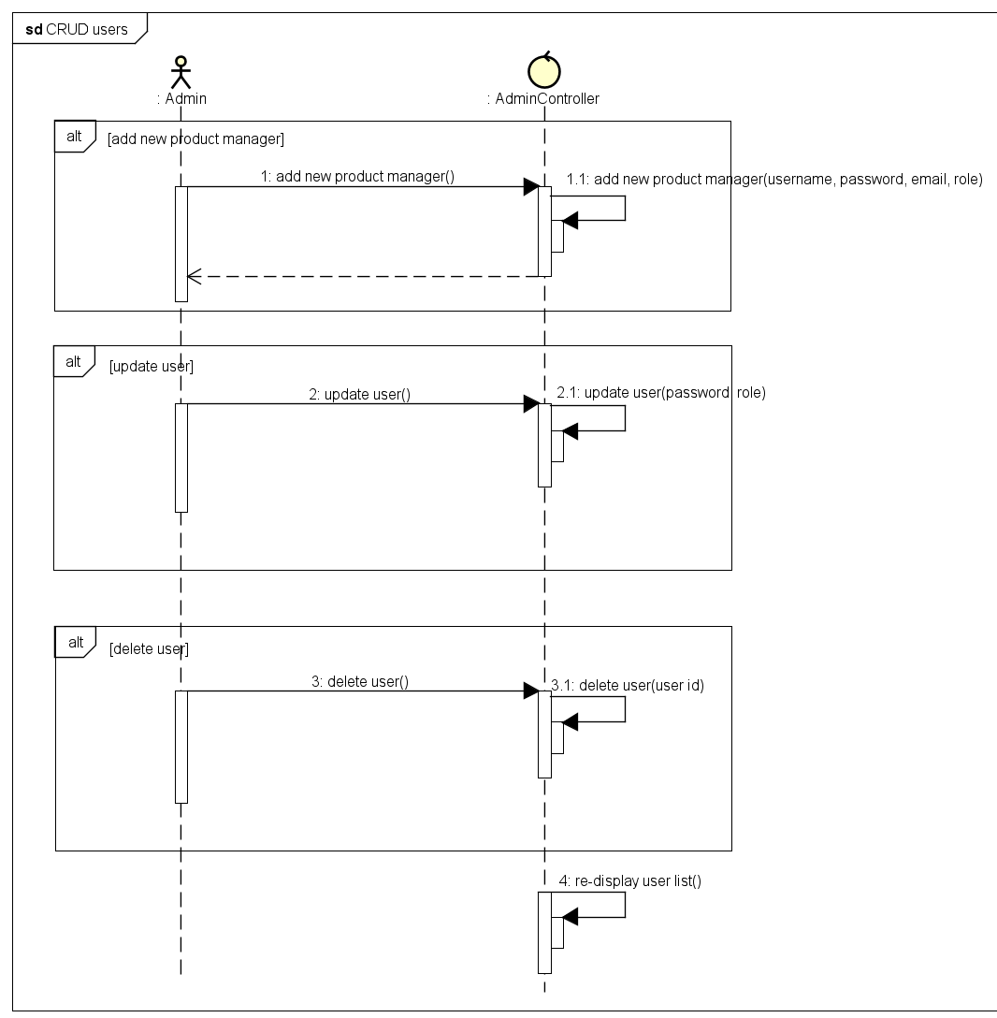

Figure 11 CRUD users sequence diagram

3.2.12 Change password

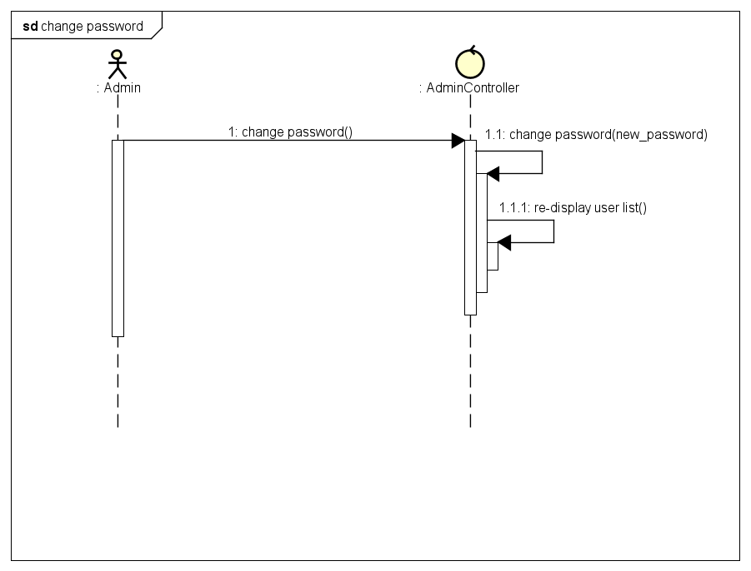

Figure 12 Change password sequence diagram

## Analysis Class Diagrams

3.3.1 Package Entity

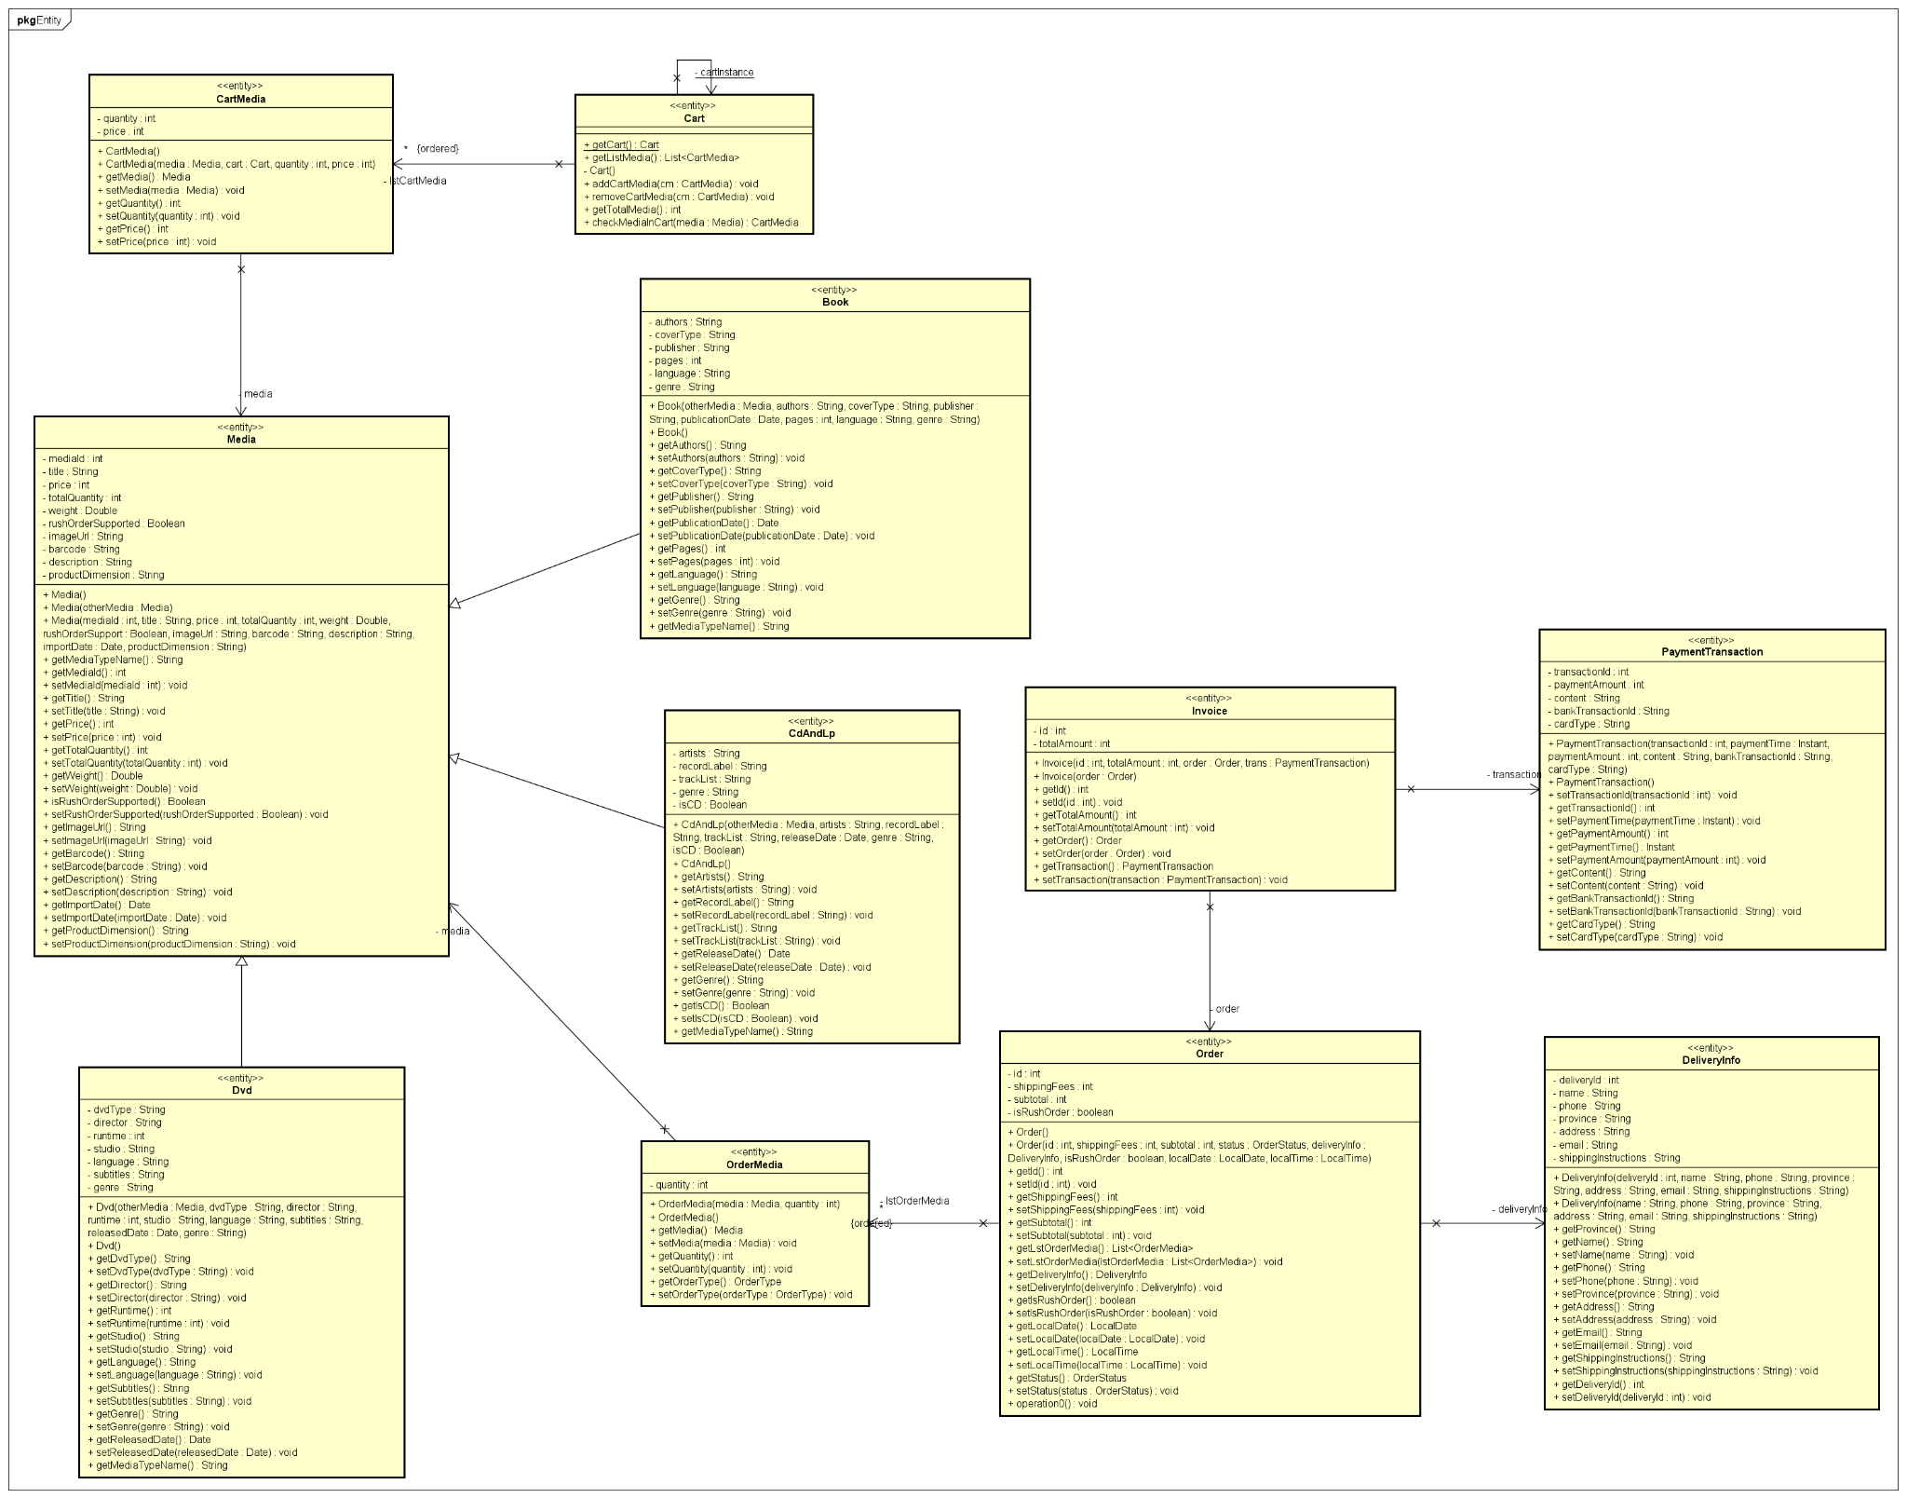

Figure 13 Analysis entity class diagram

3.3.2 Package Controller

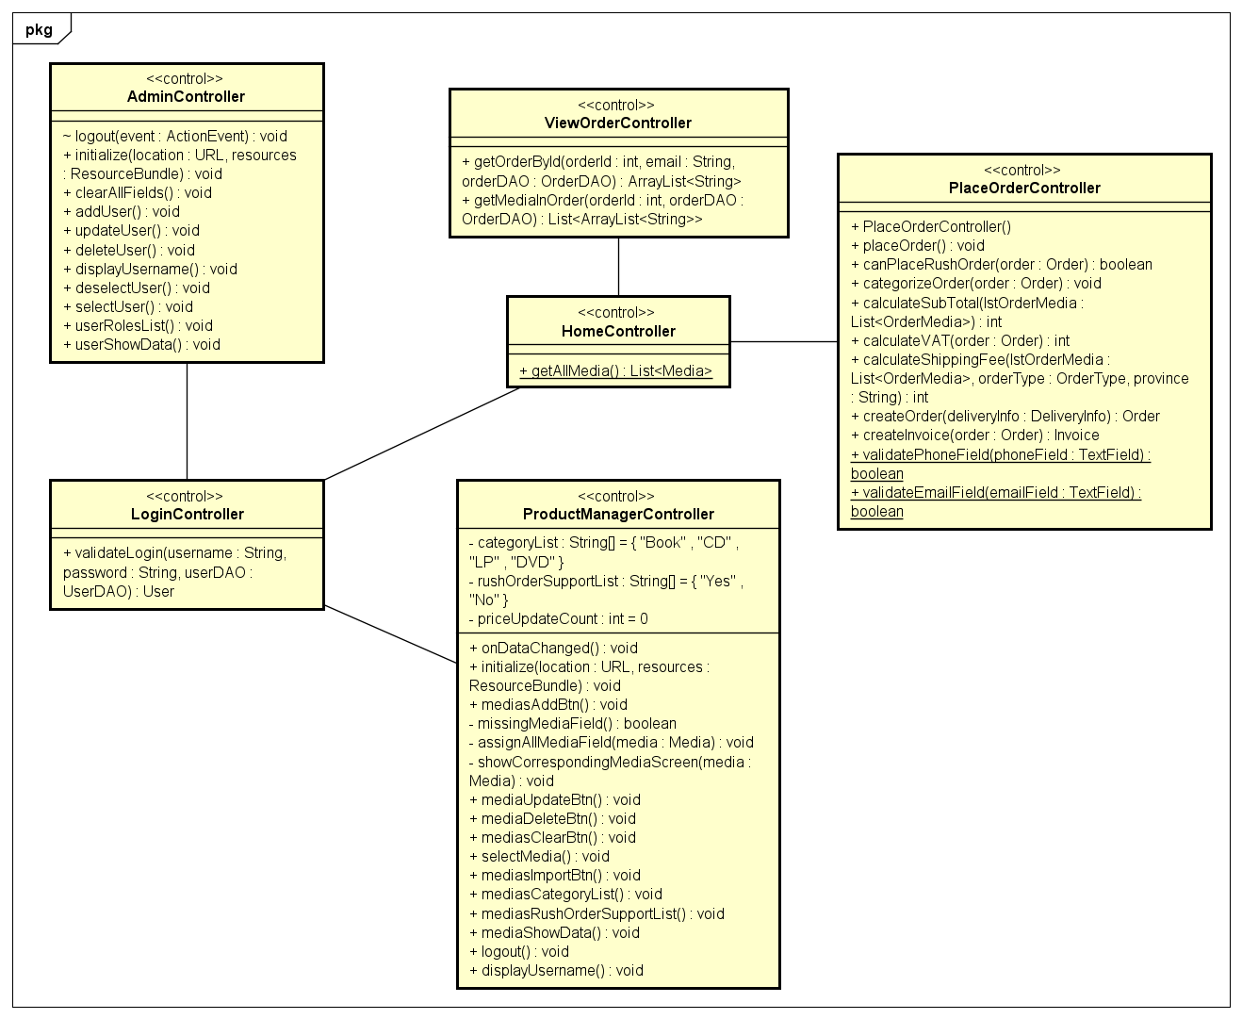

Figure 14 Analysis controller class diagram

3.3.3 Package Boundary

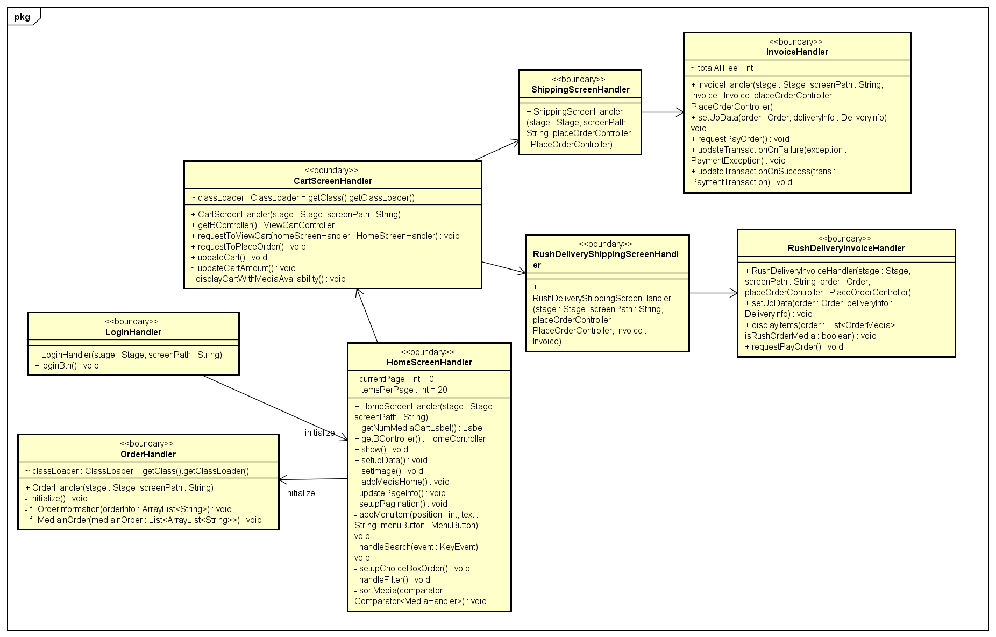

Figure 15 Analysis boundary class diagram

## Unified Analysis Class Diagram

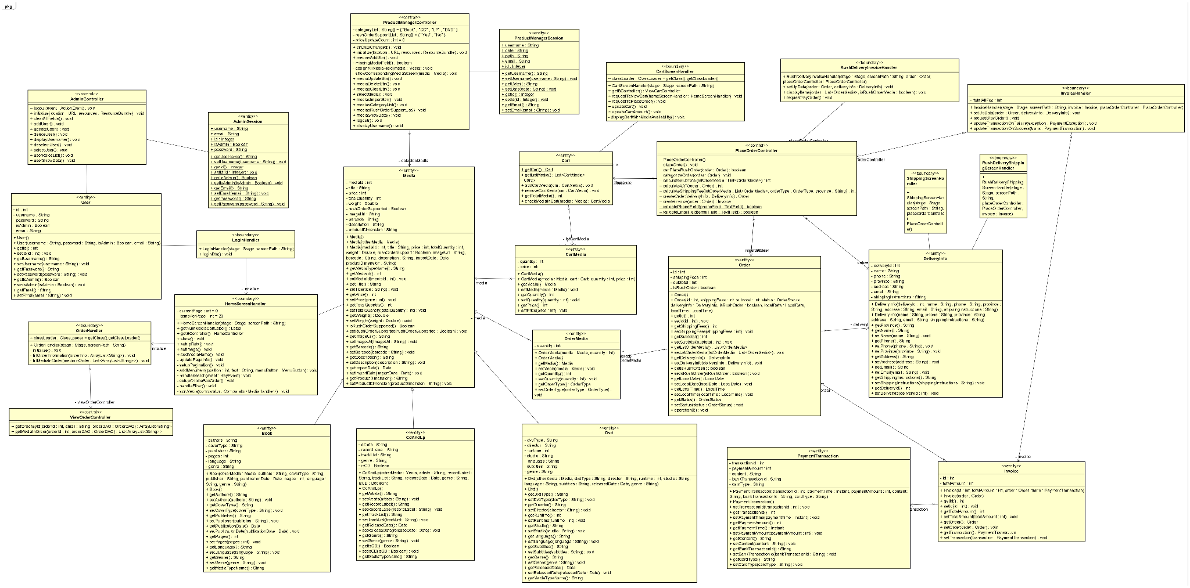

Figure 16 Unified analysis class diagram

# Detailed Design

## User Interface Design

### Screen Configuration Standardization

1. Description

This document describes the configuration of the GUI of AIMS software for use case "Place Order" and all of the use cases related to it.

2. Display

Number of colors supported: 16,777,216 colors

Resolution: 1366 × 768 pixels

3. Screen

Location of standard buttons: At the bottom (vertically) and in the middle (horizontally) of the frame.

Location of the messages: Starting from the top vertically and in the middle horizontally of the frame down to the bottom.

Display of the screen title: The title is located at the top of the frame under the header.

Consistency in expression of alphanumeric numbers: comma for separator of thousand while strings only consist of characters, digits, commas, dots, spaces, underscores, and hyphen symbol.

Header: located right at the top (vertically) of the screen with the width is fit to the parent.

Footer: located right at the bottom (vertically) of the screen with the width is fit to the parent.

4. Control

Size of the text: medium size (at most 24px). Font: Arial. Color: #000000.

Background of standard button: background color: #c82905.

Input check process: Should check if it is empty or not. Next, check if the input is in the correct format or not.

Hover: hand sign.

Sequence of moving the focus: There will be no stack frames. Each screen will be separated. However, the manual is considered a popup message, as the main screen cannot be operated while the manual screen is shown. After the opening screen, the app will start with a splash screen, and then the first screen (home screen) will appear.

5. Error

A message will be given to notify the users what is the problem with a pop-up.

6. Direct input from the keyboard

There will be no shortcuts. There are back buttons to move back to the previous screen. Also, there is the close button “X” located at the title bar to the right to close the screen.

### Screen Transition Diagrams

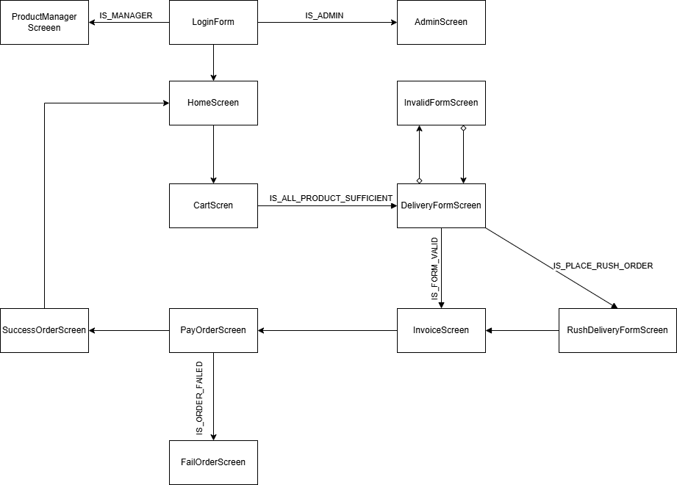

Figure 17 Screen transition diagram

### Screen Specifications

Table 2 Cart Screen

|  |  |  |  |  |
| --- | --- | --- | --- | --- |
| **AIMS SOFTWARE** | | | | |
| **Screen specification** | | | CartScreen | |
| **Date of creation** | **Approved by** | | **Reviewed by** | **Person in charge** |
| 07/04/2024 |  | |  | Group 10 |
|  | | | | |
| **Control** | | **Operation** | | **Function** |
| Area for display the list of products in the cart | | Initialization | | Display products in the cart. |
| Quantity spinner | | Select | | Display a product quantity in the cart. |
| Remove button | | Click | | Remove the product from the cart |
| Area for displaying subtotal and total | | Initialization | | Display the amount that has to paid |
| Button for place order | | Click | | Move to DeliveryFormScreen |

Table 3 Delivery Form Screen

|  |  |  |  |  |  |
| --- | --- | --- | --- | --- | --- |
| **AIMS SOFTWARE** | | | | | |
| **Screen specification** | | | DeliveryFormScreen | | |
| **Date of creation** | **Approved by** | | **Reviewed by** | | **Person in charge** |
| 07/04/2024 |  | |  | | Group 10 |
|  | | | | | |
| **Control** | | **Operation** | | **Function** | |
| Area for delivery form display | | Initialization | | Display the form for delivery | |
| “Full name” attribute | | Input | | Allow user to input name | |
| “Phone number” attribute | | Input | | Allow user to input phone number | |
| “Province” attribute | | Select | | Allow user to select province | |
| “Address” attribute | | Input | | Allow user to input address | |
| “Shipping instruction” attribute | | Input | | Allow user to input shipping instruction | |
| “Continue” button | | Click | | Move to InvoiceScreen | |
| “Place Rush Order” button | | Click | | Move to RushDeliveryForm | |

Table 4 Rush Delivery Form Screen

|  |  |  |  |  |  |
| --- | --- | --- | --- | --- | --- |
| **AIMS SOFTWARE** | | | | | |
| **Screen specification** | | | RushDeliveryFormScreen | | |
| **Date of creation** | **Approved by** | | **Reviewed by** | | **Person in charge** |
| 07/04/2024 |  | |  | | Group 10 |
|  | | | | | |
| **Control** | | **Operation** | | **Function** | |
| Area for rush delivery form display | | Initialization | | Display rush delivery form with one more attribute | |
| “Rush delivery time” | | Select | | Select the date for rush time | |
| “Continue” | | Click | | Move to InvoiceScreen | |

* The other control in this form is inherited from the previous DeliveryFormScreen.

Table 5 Invoice Screen

|  |  |  |  |  |  |
| --- | --- | --- | --- | --- | --- |
| **AIMS SOFTWARE** | | | | | |
| **Screen specification** | | | InvoiceScreen | | |
| **Date of creation** | **Approved by** | | **Reviewed by** | | **Person in charge** |
| 07/04/2024 |  | |  | | Group 10 |
|  | | | | | |
| **Control** | | **Operation** | | **Function** | |
| Area for list of products in the order | | Initialization | | Display the products in the order | |
| Delivery Information | | Initialization | | Display the delivery form information from the customer | |
| Area for total fee | | Initialization | | Display the amount, shipping fee and total must pay | |
| “Pay the invoice” button | | Click | | Move to PayOrderScreen. | |

Table 6 Pay Order Form

|  |  |  |  |  |  |
| --- | --- | --- | --- | --- | --- |
| **AIMS SOFTWARE** | | | | | |
| **Screen specification** | | | PayOrderForm | | |
| **Date of creation** | **Approved by** | | **Reviewed by** | | **Person in charge** |
| 07/04/2024 |  | |  | | Group 10 |
|  | | | | | |
| **Control** | | **Operation** | | **Function** | |
| Area for total fee display | | Initialization | | Display amount the customer must pay. | |
| “Cardholder name” | | Input | | Allow input name in the card. | |
| “Card number” | | Input | | Allow the input number of the card. | |
| “Expired date” | | Input | | Allow to input the expiration date in the card. | |
| “Payment method” | | Radio | | Default credit card. | |
| “Continue with VNPAY” | | Click | | Move to the boundary of VNPAY to process the transaction. | |

Table 7 Success Order Screen

|  |  |  |  |  |  |
| --- | --- | --- | --- | --- | --- |
| **AIMS SOFTWARE** | | | | | |
| **Screen specification** | | | SuccessOrderScreen | | |
| **Date of creation** | **Approved by** | | **Reviewed by** | | **Person in charge** |
| 07/04/2024 |  | |  | | Group 10 |
|  | | | | | |
| **Control** | | **Operation** | | **Function** | |
| Area to display the status of order | | Initialization | | Display the status of the order and the information of the transaction. | |
| “Ok” button | | Click | | Move to HomeScreen. | |

Table 8 Invalid Form Screen

|  |  |  |  |  |  |
| --- | --- | --- | --- | --- | --- |
| **AIMS SOFTWARE** | | | | | |
| **Screen specification** | | | InvalidFormScreen | | |
| **Date of creation** | **Approved by** | | **Reviewed by** | | **Person in charge** |
| 07/04/2024 |  | |  | | Group 10 |
|  | | | | | |
| **Control** | | **Operation** | | **Function** | |
| Message | | Initialization | | Display the error content | |
| “OK” button | | Click | | Move to the previous screen | |

Table 9 Invalid Rush Order Screen

|  |  |  |  |  |  |
| --- | --- | --- | --- | --- | --- |
| **AIMS SOFTWARE** | | | | | |
| **Screen specification** | | | InvalidFormScreen | | |
| **Date of creation** | **Approved by** | | **Reviewed by** | | **Person in charge** |
| 07/04/2024 |  | |  | | Group 10 |
|  | | | | | |
| **Control** | | **Operation** | | **Function** | |
| Message | | Initialization | | Display the error content | |
| “OK” button | | Click | | Move to the previous screen | |

Table 10 Login Screen

|  |  |  |  |  |
| --- | --- | --- | --- | --- |
| **AIMS SOFTWARE** | | | | |
| **Screen specification** | | | LoginScreen | |
| **Date of creation** | **Approved by** | | **Reviewed by** | **Person in charge** |
| 07/04/2024 |  | |  | Group 10 |
|  | | | | |
| **Control** | | **Operation** | | **Function** |
| Button Login | | Click | | Login |
| “Username” attribute | | Input | | Allow user to input name |
| “Password” attribute | | Input | | Allow user to input password |
| Login as guest | | Click | | Login as guest |

Table 11 Home Screen

|  |  |  |  |  |
| --- | --- | --- | --- | --- |
| **AIMS SOFTWARE** | | | | |
| **Screen specification** | | | HomeScreen | |
| **Date of creation** | **Approved by** | | **Reviewed by** | **Person in charge** |
| 07/04/2024 |  | |  | Group 10 |
|  | | | | |
| **Control** | | **Operation** | | **Function** |
| Area for display the list of products | | Initialization | | Display products. |
| Quantity spinner | | Select | | Display a product quantity in the cart. |
| Button Add to cart | | Click | | Add product to cart |
| Button Cart | | Click | | View cartScreen |
| Button Order | | Click | | View Order |
| Button search | | Click | | Search product |
| Button Ascending | | Click | | Sort product with price |

Table 12 Admin Screen

|  |  |  |  |  |
| --- | --- | --- | --- | --- |
| **AIMS SOFTWARE** | | | | |
| **Screen specification** | | | AdminScreen | |
| **Date of creation** | **Approved by** | | **Reviewed by** | **Person in charge** |
| 07/04/2024 |  | |  | Group 10 |
|  | | | | |
| **Control** | | **Operation** | | **Function** |
| Area for display the list of account | | Initialization | | Display account. |
| Button Add | | Click | | Add Account |
| Button Update | | Click | | Update Account |
| Button Delete | | Click | | Delete Account |
| Button Logout | | Click | | Logout |
| “Username” attribute | | Input | | Allow user to input user |
| “Password” attribute | | Input | | Allow user to input password |
| “Email” attribute | | Input | | Allow user to input email |
| “Role” attribute | | Input | | Allow user to input role |

Table 13 Product Manager Screen

|  |  |  |  |  |
| --- | --- | --- | --- | --- |
| **AIMS SOFTWARE** | | | | |
| **Screen specification** | | | ProductmanagerScreen | |
| **Date of creation** | **Approved by** | | **Reviewed by** | **Person in charge** |
| 07/04/2024 |  | |  | Group 10 |
|  | | | | |
| **Control** | | **Operation** | | **Function** |
| Area for display the list of account | | Initialization | | Display account. |
| Button Add | | Click | | Add media |
| Button Update | | Click | | Update media |
| Button Delete | | Click | | Delete media |
| Button Logout | | Click | | Logout |
| “Title” attribute | | Input | | Allow user to input title |
| “quantity” attribute | | Input | | Allow user to input quantity |
| “category” attribute | | Input | | Allow user to input category |
| “price” attribute | | Input | | Allow user to input price |
| “Rush order support” attribute | | Input | | Allow user to input rush order support |
| “Rush order support” attribute | | Input | | Allow user to input rush order support |
| “Dimension” attribute | | Input | | Allow user to input dimension |
| “Barcode” attribute | | Input | | Allow user to input Barcode |
| “Description” attribute | | Input | | Allow user to input Description |
| “Weight” attribute | | Input | | Allow user to input Description |
| Button import | | Click | | Import image |

Table 14 Change Account Password Screen

|  |  |  |  |  |
| --- | --- | --- | --- | --- |
| **AIMS SOFTWARE** | | | | |
| **Screen specification** | | | Change Account Password Screen | |
| **Date of creation** | **Approved by** | | **Reviewed by** | **Person in charge** |
| 07/04/2024 |  | |  | Group 10 |
|  | | | | |
| **Control** | | **Operation** | | **Function** |
| Area for display the list of account | | Initialization | | Display account. |
| Button Confirm | | Click | | Update password account |
| Button Cancel | | Click | | Close the change account password screen |
| “Your Account Email” attribute | | Input | | Allow user to input email |
| “Current Password” attribute | | Input | | Allow user to input current password |
| “New Password” attribute | | Input | | Allow user to input new password |
| “Confirm New Password” attribute | | Input | | Allow user to input Confirm New Password |
|  |  |  |  |  |

## Data Modeling

### Conceptual Data Modeling

Figure 18 ERD diagram

### Database Design

#### Database Management System

The decision for the Database Management System (DBMS) for this project is to use MySQL. MySQL is a widely used, open-source relational database management system known for its reliability, scalability, and ease of use. It supports a wide range of applications, from small-scale projects to large-scale enterprise systems, making it a versatile choice for our needs.

MySQL offers robust performance and security features, ensuring that data is stored efficiently and can be retrieved quickly, even under high load conditions. It supports various storage engines, including InnoDB, which provides ACID (Atomicity, Consistency, Isolation, Durability) compliance for reliable transaction processing. MySQL also offers strong data protection mechanisms, including data encryption, user authentication, and access control.

Additionally, MySQL integrates well with numerous programming languages and platforms, making it highly adaptable to different development environments. Its extensive documentation and active community support make it easier to troubleshoot issues and implement best practices. Overall, MySQL’s proven track record and comprehensive features make it the ideal choice for managing our database requirements.

#### Relational Schema

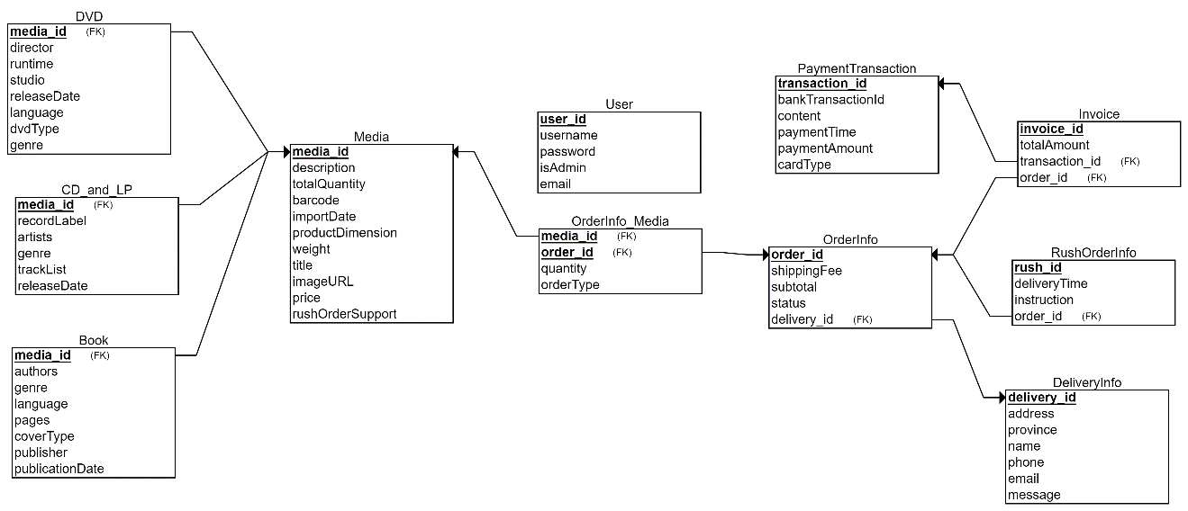

Figure 19 Database schema

#### Database Detail Design

Table 15 Media Table Details

|  |  |  |  |  |  |  |  |
| --- | --- | --- | --- | --- | --- | --- | --- |
| *#* | *PK* | *FK* | *Column name* | *Data type* | *Default value* | *Mandatory* | *Description* |
| 1 | x |  | media_id | integer |  | yes | increment |
| 2 |  |  | description | varchar |  | yes |  |
| 3 |  |  | totalQuantity | integer |  | yes |  |
| 4 |  |  | barcode | varchar |  | yes |  |
| 5 |  |  | importDate | date |  | yes |  |
| 6 |  |  | productDimension | varchar |  | yes |  |
| 7 |  |  | weight | real |  | yes |  |
| 8 |  |  | title | varchar |  | yes |  |
| 9 |  |  | imageURL | varchar |  | yes |  |
| 10 |  |  | price | integer |  | yes |  |
| 11 |  |  | rushOrderSupport | boolean |  | yes |  |

Table 16 DVD Table Details

|  |  |  |  |  |  |  |  |
| --- | --- | --- | --- | --- | --- | --- | --- |
| *#* | *PK* | *FK* | *Column name* | *Data type* | *Default value* | *Mandatory* | *Description* |
| 1 | x | x | media_id | integer |  | yes | increment |
| 2 |  |  | director | varchar |  | yes |  |
| 3 |  |  | runtime | integer |  | yes |  |
| 4 |  |  | studio | varchar |  | yes |  |
| 5 |  |  | releaseDate | date |  | yes |  |
| 6 |  |  | language | varchar |  | yes |  |
| 7 |  |  | DvdType | varchar |  | yes |  |
| 8 |  |  | genre | varchar |  | yes |  |

Table 17 CD_and_LP Table Details

|  |  |  |  |  |  |  |  |
| --- | --- | --- | --- | --- | --- | --- | --- |
| *#* | *PK* | *FK* | *Column name* | *Data type* | *Default value* | *Mandatory* | *Description* |
| 1 | x | x | media_id | integer |  | yes | increment |
| 2 |  |  | recordLabel | varchar |  | yes |  |
| 3 |  |  | artists | varchar |  | yes |  |
| 4 |  |  | genre | varchar |  | yes |  |
| 5 |  |  | trackList | varchar |  | yes |  |
| 6 |  |  | releaseDate | date |  | yes |  |

Table 18 Book Table Details

|  |  |  |  |  |  |  |  |
| --- | --- | --- | --- | --- | --- | --- | --- |
| *#* | *PK* | *FK* | *Column name* | *Data type* | *Default value* | *Mandatory* | *Description* |
| 1 | x | x | media_id | integer |  | yes | increment |
| 2 |  |  | authors | varchar |  | yes |  |
| 3 |  |  | genre | varchar |  | yes |  |
| 4 |  |  | language | varchar |  | yes |  |
| 5 |  |  | pages | int |  | yes |  |
| 6 |  |  | coverType | varchar |  | yes |  |
| 7 |  |  | publisher | varchar |  | yes |  |
| 8 |  |  | publicationDate | date |  | yes |  |

Table 19 User Table Details

|  |  |  |  |  |  |  |  |
| --- | --- | --- | --- | --- | --- | --- | --- |
| *#* | *PK* | *FK* | *Column name* | *Data type* | *Default value* | *Mandatory* | *Description* |
| 1 | x |  | user_id | integer |  | yes | increment |
| 2 |  |  | username | varchar |  | yes |  |
| 3 |  |  | password | varchar |  | yes |  |
| 4 |  |  | email | varchar |  | yes |  |
| 5 |  |  | isAdmin | boolean |  | yes |  |

Table 20 DeliveryInfo Table Details

|  |  |  |  |  |  |  |  |
| --- | --- | --- | --- | --- | --- | --- | --- |
| *#* | *PK* | *FK* | *Column name* | *Data type* | *Default value* | *Mandatory* | *Description* |
| 1 | x |  | delivery_id | integer |  | yes | increment |
| 2 |  |  | address | varchar |  | yes |  |
| 3 |  |  | province | varchar |  | yes |  |
| 4 |  |  | email | varchar |  | yes |  |
| 5 |  |  | name | varchar |  | yes |  |
| 6 |  |  | phone | varchar |  | yes |  |
| 7 |  |  | messages | varchar |  | no |  |

Table 21 OrderInfo Table Details

|  |  |  |  |  |  |  |  |
| --- | --- | --- | --- | --- | --- | --- | --- |
| *#* | *PK* | *FK* | *Column name* | *Data type* | *Default value* | *Mandatory* | *Description* |
| 1 | x |  | order_id | integer |  | yes | increment |
| 2 |  |  | status | varchar |  | yes |  |
| 3 |  |  | subtotal | integer |  | yes |  |
| 4 |  |  | shippingFee | integer |  | yes |  |
| 5 |  | x | delivery_id | integer |  | yes |  |

Table 22 RushOrderInfo Table Details

|  |  |  |  |  |  |  |  |
| --- | --- | --- | --- | --- | --- | --- | --- |
| *#* | *PK* | *FK* | *Column name* | *Data type* | *Default value* | *Mandatory* | *Description* |
| 1 | x |  | rush_id | integer |  | yes | increment |
| 2 |  | x | order_id | integer |  | yes |  |
| 3 |  |  | instruction | varchar |  | no |  |
| 4 |  |  | deliveryTime | datetime |  | yes |  |

Table 23 OrderInfo_Media Table Details

|  |  |  |  |  |  |  |  |
| --- | --- | --- | --- | --- | --- | --- | --- |
| *#* | *PK* | *FK* | *Column name* | *Data type* | *Default value* | *Mandatory* | *Description* |
| 1 |  | x | order_id | integer |  | yes |  |
| 2 |  | x | media_id | integer |  | yes |  |
| 3 |  |  | quantity | integer |  | yes |  |
| 4 |  |  | orderType | integer |  | yes |  |

Table 24 Payment Transaction Table Details

|  |  |  |  |  |  |  |  |
| --- | --- | --- | --- | --- | --- | --- | --- |
| *#* | *PK* | *FK* | *Column name* | *Data type* | *Default value* | *Mandatory* | *Description* |
| 1 | x |  | transaction_id | integer |  | yes | increment |
| 2 |  |  | bankTransactionId | integer |  | yes |  |
| 3 |  |  | quantity | integer |  | yes |  |
| 4 |  |  | content | varchar |  | yes |  |
| 5 |  |  | paymentTime | datetime |  | yes |  |
| 6 |  |  | paymentAmount | integer |  | yes |  |
| 7 |  |  | cardType | varchar |  |  |  |

Table 25 Invoice Table Details

|  |  |  |  |  |  |  |  |
| --- | --- | --- | --- | --- | --- | --- | --- |
| *#* | *PK* | *FK* | *Column name* | *Data type* | *Default value* | *Mandatory* | *Description* |
| 1 | x |  | invoice_id | integer |  | yes | increment |
| 2 |  | x | transaction_id | integer |  | yes |  |
| 3 |  | x | order_id | integer |  | yes |  |
|  |  |  | totalAmount | integer |  | yes |  |

**INDEX**

*-***- Index: delivery_id_index**

CREATE INDEX delivery_id_index ON OrderInfo (delivery_id);

**-- Index: transaction_id_index, order_id_index**

CREATE INDEX invoice_transaction_id_index ON Invoice (transaction_id);

CREATE INDEX invoice_order_id_index ON Invoice (order_id);

**-- Index: order_id_index**

CREATE INDEX rush_order_id_index ON RushOrderInfo (order_id);

## Class Design

### General Class Diagram

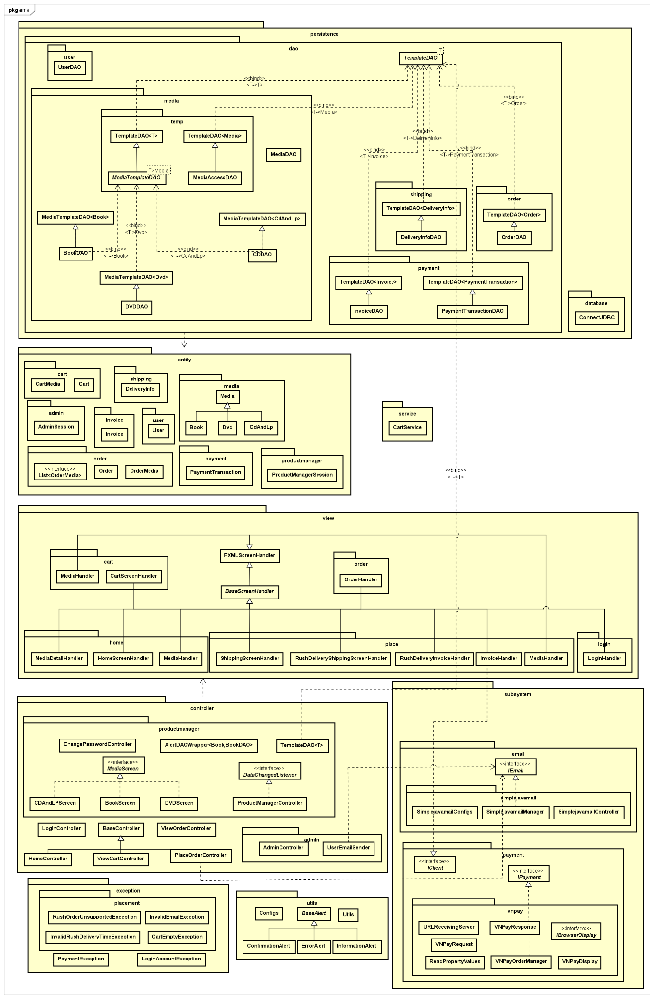

Figure 20 General Class Diagram

### Class Diagrams

#### Class Diagram for Controller



Figure 21 Class diagram for Controller

#### Class Diagram for Entity



Figure 22 Class diagram for Entity

* + - 1. ***Class Diagram for Boundary***



Figure 23 Class diagram for Boundary

### Class Diagram for SubSystem

### 4.3.3.1.Email SubSystem

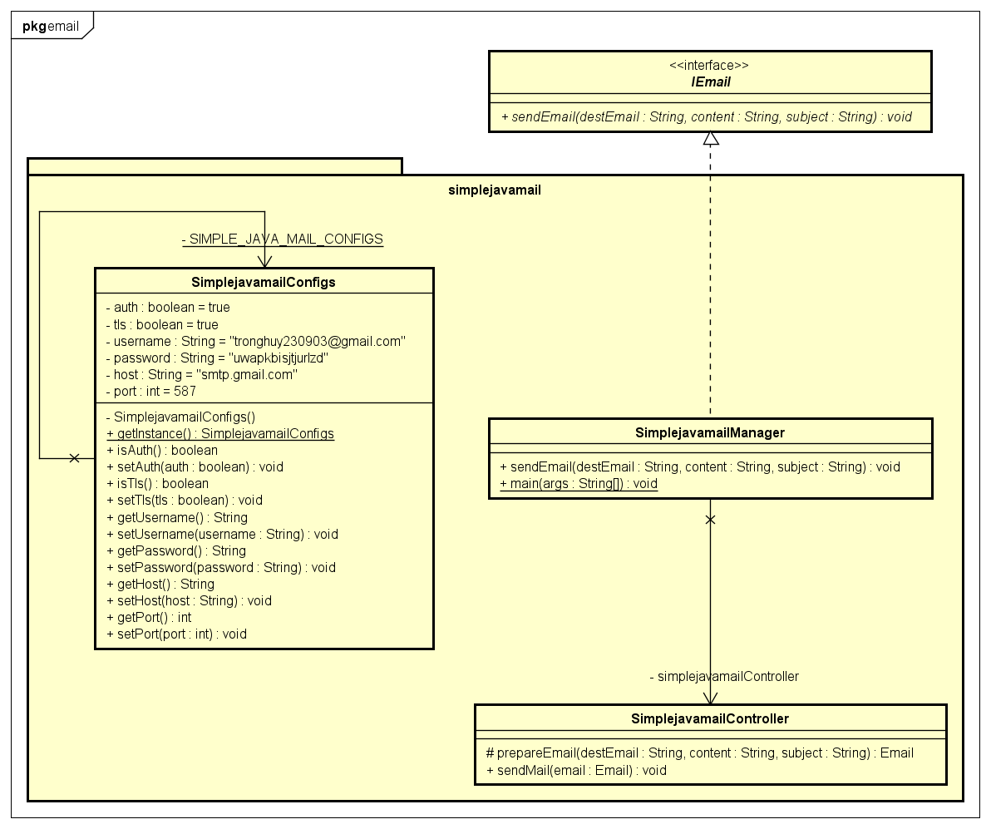

Figure 24 Email Subsystem Design

### 4.3.3.2. Payment SubSystem

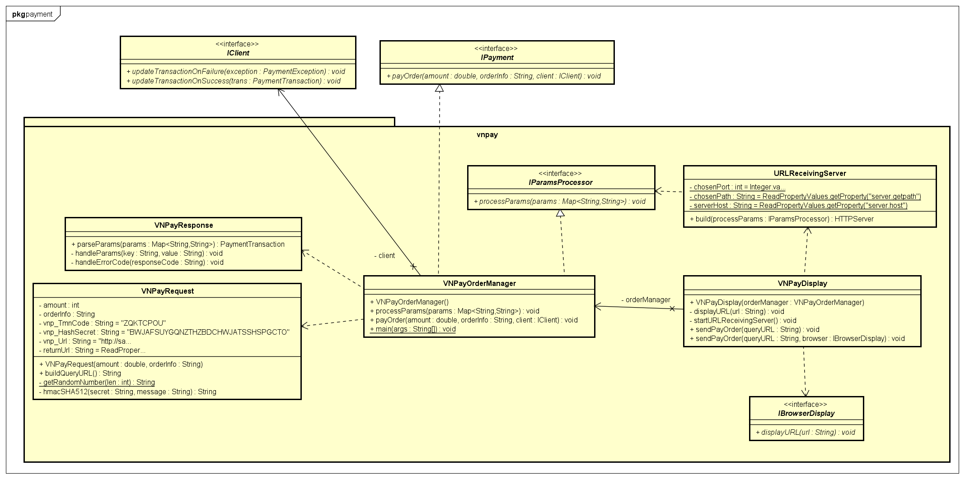

Figure 25 Payment Subsystem Design

## Class Design Details

#### Class “Controller”

**- Methods for AdminController**

* + **Method 1:**
* **Name:** logout(event)
* **Return type:** void
* **Description:** Logs out the user
* **Method 2:**
* **Name:** initialize(location, resources)
* **Return type:** void
* **Description:** Initializes the controller
* **Method 3:**
* **Name:** ResourceBundle
* **Return type:** void
* **Description:** ResourceBundle for localization
* **Method 4:**
* **Name:** addUser()
* **Return type:** void
* **Description:** Adds a user
* **Method 5:**
* **Name:** updateUser()
* **Return type:** void
* **Description:** Updates a user
* **Method 6:**
* **Name:** deleteUser()
* **Return type:** void
* **Description:** Deletes a user
* **Method 7:**
* **Name:** displayUsername()
* **Return type:** void
* **Description:** Displays the username
* **Method 8:**
* **Name:** selectUser()
* **Return type:** void
* **Description:** Selects a user
* **Method 9:**
* **Name:** userRoles()
* **Return type:** void
* **Description:** Manages user roles
* **Method 10:**
* **Name:** userShowData()
* **Return type:** void
* **Description:** Shows user data
* **Methods for LoginController**
  + **Method 11:**
* **Name:** validateLogin(username, password)
* **Return type:** User
* **Description:** Validates login credentials
* **Methods for HomeController**
  + **Method 12:**
* **Name:** getAllMedia()
* **Return type:** List<Media>
* **Description:** Retrieves all media items
* **Methods for PlaceOrderController**
  + **Method 13:**
* **Name:** PlaceOrderController()
* **Return type:** Constructor
* **Description:** Constructor method
* **Method 14:**
* **Name:** placeOrder()
* **Return type:** void
* **Description:** Places an order
* **Method 15:**
* **Name:** canPlaceRushOrder(order)
* **Return type:** boolean
* **Description:** Checks if a rush order can be placed
* **Method 16:**
* **Name:** calculateOrderSubtotal(order)
* **Return type:** void
* **Description:** Calculates the order subtotal
* **Method 17:**
* **Name:** listOrderMethods()
* **Return type:** List<String>
* **Description:** Lists the order methods
* **Method 18:**
* **Name:** calculateVAT(order)
* **Return type:** void
* **Description:** Calculates VAT for the order
* **Method 19:**
* **Name:** calculateShipping(order)
* **Return type:** void
* **Description:** Calculates shipping cost for the order
* **Method 20:**
* **Name:** createOrder(deliveryInfo)
* **Return type:** Invoice
* **Description:** Creates an order with delivery information
* **Method 21:**
* **Name:** validatePhoneField(phoneField)
* **Return type:** boolean
* **Description:** Validates the phone field input
* **Method 22:**
* **Name:** validateEmailField(emailField)
* **Return type:** boolean
* **Description:** Validates the email field input
* **Methods for ProductManagerController**
  + **Method 23:**
* **Name:** ProductManagerController()
* **Return type:** Constructor
* **Description:** Constructor method
* **Method 24:**
* **Name:** initialize(location, resources)
* **Return type:** void
* **Description:** Initializes the controller
* **Method 25:**
* **Name:** ResourceBundle
* **Return type:** void
* **Description:** ResourceBundle for localization
* **Method 26:**
* **Name:** missingField(fieldName)
* **Return type:** boolean
* **Description:** Checks if a required field is missing
* **Method 27:**
* **Name:** missingMediaField(media)
* **Return type:** void
* **Description:** Checks if media field is missing
* **Method 28:**
* **Name:** showMediaScreen(media)
* **Return type:** void
* **Description:** Displays the media screen
* **Method 29:**
* **Name:** mediaUpdated()
* **Return type:** void
* **Description:** Updates media information
* **Method 30:**
* **Name:** mediaDeleted()
* **Return type:** void
* **Description:** Deletes media information
* **Method 31:**
* **Name:** mediaSelected()
* **Return type:** void
* **Description:** Selects media information
* **Method 32:**
* **Name:** mediaRushOrderSupportList()
* **Return type:** void
* **Description:** Lists media with rush order support
* **Method 33:**
* **Name:** displayUsername()
* **Return type:** void
* **Description:** Displays the username
* **Methods for ViewOrderController**
  + **Method 34:**
* **Name:** getOrderById(orderId, email)
* **Return type:** Order
* **Description:** Retrieves an order by ID
* **Method 35:**
* **Name:** getOrderDAO()
* **Return type:** ArrayList<String>
* **Description:** Gets the Order Data Access Object
* **Method 36:**
* **Name:** getMediaInOrder(orderId)
* **Return type:** List<ArrayList<String>>
* **Description:** Retrieves media items in the order

#### Class “Entity”

* **CartScreenHandler**
  + Attributes:
    - stage
    - screenPath
    - cartController
  + Methods:
    - CartScreenHandler(stage, screenPath): Constructor for CartScreenHandler
    - requestToViewCart(homeScreenHandler): Handles the request to view the cart
    - requestToPlaceOrder(homeScreenHandler): Handles the request to place an order
    - initialize(): Initializes the CartScreenHandler
    - updateCart(): Updates the cart
    - displayCartMedia(mediaHandlerList): Displays the cart media
* **LoginHandler**
  + Attributes:
    - stage
    - screenPath
  + Methods:
    - LoginHandler(stage, screenPath): Constructor for LoginHandler
    - login(): Handles the login process
* **OrderHandler**
  + Attributes:
    - stage
    - screenPath
  + Methods:
    - OrderHandler(stage, screenPath): Constructor for OrderHandler
    - getOrderInformation(orderId): Retrieves order information
    - viewOrderDetails(orderId): Views order details
* **HomeScreenHandler**
  + Attributes:
    - stage
    - screenPath
    - user
    - mediaController
    - orderController
    - userController
  + Methods:
    - HomeScreenHandler(stage, screenPath, user): Constructor for HomeScreenHandler
    - initialize(): Initializes the HomeScreenHandler
    - logout(): Handles user logout
    - goToCart(): Navigates to the cart screen
    - goToOrderHistory(): Navigates to the order history screen
    - goToUserProfile(): Navigates to the user profile screen
    - viewCart(): Displays the cart
    - viewMedia(media): Displays the media details
    - searchMedia(keyword): Searches for media based on the keyword
      1. **Class “BoundPackage”**
* **CartScreenHandler**
  + Attributes: classLoader, prevStage, cartController
  + Methods:
    - CartScreenHandler(stage, screenPath): Constructor for CartScreenHandler
    - requestToViewCart(homeScreenHandler): Handles the request to view the cart
    - requestToPlaceOrder(homeScreenHandler): Handles the request to place an order
    - initialize(): Initializes the CartScreenHandler
    - updateCart(): Updates the cart
    - displayCartMedia(mediaHandlerList): Displays the cart media
* **LoginHandler**
  + Attributes: classLoader
  + Methods:
    - LoginHandler(stage, screenPath): Constructor for LoginHandler
    - login(): Handles the login process
* **OrderHandler**
  + Attributes: classLoader
  + Methods:
    - OrderHandler(stage, screenPath): Constructor for OrderHandler
    - getOrderInformation(orderId): Retrieves order information
    - viewOrderDetails(orderId): Views order details
* **HomeScreenHandler**
  + Attributes: user, mediaController, orderController, userController
  + Methods:
    - HomeScreenHandler(stage, screenPath, user): Constructor for HomeScreenHandler
    - initialize(): Initializes the HomeScreenHandler
    - logout(): Handles user logout
    - goToCart(): Navigates to the cart screen
    - goToOrderHistory(): Navigates to the order history screen
    - goToUserProfile(): Navigates to the user profile screen
    - viewCart(): Displays the cart
    - viewMedia(media): Displays the media details
    - searchMedia(keyword): Searches for media based on the keyword
* **ShippingScreenHandler**
  + Attributes: placeOrderController
  + Methods:
    - ShippingScreenHandler(stage, screenPath, placeOrderController):Constructor for ShippingScreenHandler
    - toConfirmOrder(): Navigates to the confirm order screen
* **RunDeliveryScreenHandler**
  + Attributes: placeOrderController, invoice
  + Methods:
    - RunDeliveryScreenHandler(stage, screenPath, placeOrderController, invoice): Constructor for RunDeliveryScreenHandler
    - viewOrderDetails(): Views order details
    - confirmOrder(): Confirms the order
    - cancelOrder(): Cancels the order
    - initialize(): Initializes the RunDeliveryScreenHandler
* **RunDeliveryShippingScreenHandler**
  + Attributes: placeOrderController, invoice
  + Methods:
    - RunDeliveryShippingScreenHandler(stage, screenPath, placeOrderController, invoice): Constructor for RunDeliveryShippingScreenHandler
    - confirmOrder(): Confirms the order
    - cancelOrder(): Cancels the order
    - initialize(): Initializes the RunDeliveryShippingScreenHandler
      1. **Class “Payment”**
* **CartScreenHandler**
  + Attributes: classLoader, prevStage, cartController
  + Methods:
    - CartScreenHandler(stage, screenPath): Constructor for CartScreenHandler
    - requestToViewCart(homeScreenHandler): Handles the request to view the cart
    - requestToPlaceOrder(homeScreenHandler): Handles the request to place an order
    - initialize(): Initializes the CartScreenHandler
    - updateCart(): Updates the cart
    - displayCartMedia(mediaHandlerList): Displays the cart media
* **LoginHandler**
  + Attributes: classLoader
  + Methods:
    - LoginHandler(stage, screenPath): Constructor for LoginHandler
    - login(): Handles the login process
* **OrderHandler**
  + Attributes: classLoader
  + Methods:
    - OrderHandler(stage, screenPath): Constructor for OrderHandler
    - getOrderInformation(orderId): Retrieves order information
    - viewOrderDetails(orderId): Views order details
* **HomeScreenHandler**
  + Attributes: user, mediaController, orderController, userController
  + Methods:
    - HomeScreenHandler(stage, screenPath, user): Constructor for HomeScreenHandler
    - initialize(): Initializes the HomeScreenHandler
    - logout(): Handles user logout
    - goToCart(): Navigates to the cart screen
    - goToOrderHistory(): Navigates to the order history screen
    - goToUserProfile(): Navigates to the user profile screen
    - viewCart(): Displays the cart
    - viewMedia(media): Displays the media details
    - searchMedia(keyword): Searches for media based on the keyword

# Design Considerations

## Goals and Guidelines

The design of the system and its software is driven by several overarching goals, guidelines, principles, and priorities aimed at achieving a balance between performance, usability, maintainability, and security.

**Goals**

- Performance Optimization: The system is designed with an emphasis on speed and responsiveness. This priority ensures that user interactions are processed quickly, enhancing the overall user experience. Performance optimization includes efficient database queries, caching mechanisms, and minimizing the overhead in data processing and network communication.

- Scalability: The system architecture is designed to scale efficiently to accommodate growing numbers of users and data. This involves modular design, use of scalable technologies like MySQL for the database, and cloud infrastructure that can expand as needed.

- Security and Privacy: Ensuring the security and privacy of user data is a top priority. The system incorporates strong encryption protocols, robust authentication and authorization mechanisms, and comprehensive logging and auditing practices to protect sensitive information and comply with relevant regulations.

- User-Friendly Interface: The system aims to provide an intuitive and consistent user interface. This goal ensures that users can easily navigate and interact with the system, reducing the learning curve and improving overall satisfaction.

**Guidelines**

- Coding Standards: Adherence to coding guidelines and conventions is essential for maintaining code quality and readability. The use of standardized naming conventions, consistent code formatting, and thorough documentation helps in reducing errors and facilitates easier code reviews and maintenance.

- Modular Design: The system follows a modular design approach, where functionality is divided into discrete, self-contained modules. This guideline aids in isolating different parts of the system, making it easier to manage, test, and update individual components without affecting the overall system.

- Error Handling: Implementing robust error handling mechanisms ensures that the system can gracefully recover from unexpected issues and provide meaningful feedback to users and developers. This includes logging errors for diagnostics and providing user-friendly error messages.

## Architectural Strategies

**Programming Language and Frameworks**

The system is developed using Java as the primary programming language, with JavaFX for building the graphical user interface (GUI). This combination leverages Java's robustness and platform independence along with JavaFX's rich set of UI components and capabilities for creating modern, responsive, and user-friendly desktop applications. The project is managed using Maven, which facilitates dependency management, builds automation, and overall project management.

**Database Management System**

As previously mentioned, the system uses MySQL as the DBMS. MySQL’s reliability, performance, and strong support for ACID transactions make it suitable for our needs. Additionally, MySQL’s compatibility with a wide range of applications and its robust security features align with our security and scalability goals.

**User Interface Paradigms**

The user interface follows a Rich Client Application paradigm using JavaFX. This approach provides a rich and interactive user experience with dynamic content updates and a responsive design. JavaFX allows for the creation of sophisticated GUI components, ensuring that the application is both functional and visually appealing. The design adheres to usability and accessibility principles to cater to a broad user base.

**Error Detection and Recovery**

The system incorporates comprehensive error detection and recovery mechanisms. In Java, try-catch blocks are used extensively to handle exceptions gracefully, providing meaningful feedback to users and logging errors for developers to review. JavaFX's built-in error handling capabilities ensure that UI-related errors do not crash the entire application, maintaining a smooth user experience.

**Testing with JUnit**

The system employs JUnit for unit testing, ensuring the reliability and correctness of the codebase. JUnit is an open-source testing framework for Java that provides an efficient way to write and run repeatable tests. The use of JUnit offers several benefits:

- Automated Testing: JUnit allows developers to write test cases that can be automatically executed, ensuring that the code functions as expected without manual intervention.

- Test Coverage: By writing comprehensive unit tests, the system can achieve high test coverage, identifying potential bugs and issues early in the development cycle.

**Version Control with GitHub and 'Feature/Release' Workflow**

The system uses Git for version control, hosted on GitHub to manage the source code efficiently and collaboratively. GitHub serves as a central repository where developers can push their changes, ensuring everyone has access to the latest version of the codebase. The version control process involves creating branches for new features or bug fixes, making and committing changes locally, and then pushing these changes to GitHub. Pull requests (PRs) facilitate code review and discussions before changes are merged into the main branch, maintaining high code quality and consistency.

The project follows a 'feature/release' workflow to streamline development and deployment. For new features or fixes, developers create a dedicated branch (feature/feature-name) from the main branch. Once development is complete, a PR is submitted for peer review. Upon approval, the feature branch is merged back into the main branch. For releases, a release/release-version branch is created, incorporating all approved features and fixes. This branch undergoes thorough testing and bug fixing before being merged into the main branch and tagged for release. This workflow ensures organized development, efficient collaboration, and smooth, stable releases.

## Coupling and Cohesion

**Coupling**

The system is designed to achieve low coupling between its components. Low coupling is essential for enhancing modularity, making the system easier to maintain, extend, and test. Evidence of low coupling in the design includes:

Modular Architecture: The use of distinct modules for different functionalities (e.g., UI with JavaFX, backend logic with Java, and data persistence with MySQL) ensures that changes in one module have minimal impact on others.

Interfaces and Abstraction: Key components interact through well-defined interfaces and abstract classes, reducing direct dependencies. For example, data access objects (DAOs) interact with the database via Hibernate, which abstracts the underlying database operations.

**Cohesion**

The design aims for high cohesion within each component, ensuring that each module or class is focused on a single task or closely related tasks. High cohesion improves code readability, maintainability, and reusability. Evidence of high cohesion includes:

Single Responsibility Principle: Classes and methods are designed to have a single responsibility. For instance, UI controllers in JavaFX handle user interactions, while service classes encapsulate business logic.

Consistent Design Patterns: The use of design patterns like Entity - Boundary - Controller (EBC) ensures that the system’s structure promotes high cohesion.

## Design Patterns

1. Singleton design pattern

Figure 26 Singleton for Cart class

Figure 27 Singleton for SimplejavamailConfig class

The Singleton design pattern ensures a class has only one instance while providing a global point of access to that instance. This is particularly beneficial in scenarios where a single object is needed to coordinate actions across a system, such as logging, configuration management, or managing connections to a resource like a database. By controlling the instantiation process, Singletons help in reducing memory overhead and potential conflicts caused by having multiple instances. They also promote consistent access and can simplify debugging and maintenance by centralizing the control logic.

2. Template Method Design Pattern

Figure 28 Template method design pattern for DAO

The Template Method design pattern defines the skeleton of an algorithm in a method, deferring some steps to subclasses. This pattern lets subclasses redefine certain steps of an algorithm without changing the algorithm's structure. It promotes code reuse and enables a high-level outline of an operation while allowing subclasses to refine or extend specific parts of the operation. By encapsulating invariant parts of an algorithm and allowing variation only in specific parts, it enhances flexibility and ensures consistent execution across different implementations. This pattern is particularly useful in scenarios where multiple classes share the same algorithm but differ in specific steps.

3. Strategy Design Pattern

Figure 29 Strategy design pattern